What stops us from helping the homeless?

Contempt - what I call “contempt” is a complicated stew of weird feelings including:
- The idea that there are able-bodied people who should be taking care of themselves, but are not. This is embodied in the “Get A Job!” exclamation we’ve heard so many times.
- The idea that our tax dollars are already paying for all the services to help people who need shelter, medical care, food etc.
- The idea that homeless people are crazy, scary and potentially dangerous – and we want them to just stay away from us.
- The idea that homeless people are just going to waste money we give them to buy alcohol or drugs.

Building Codes and Ordinances
- There is nothing difficult about building a home so a person does not have to sleep outside or in a tent. As a species, building shelter is something we mastered centuries ago! So why is there so little small and affordable housing? Because NIMBY homeowners, governments and private enterprises collude against it.
- When examining local building code and ordinances, you will notice that most communities have attempted to legislate poverty, trailer parks and low tax dwellings out of their towns. This includes square footage minimums, required building materials, such as brick exteriors, concrete driveways, high sewer hookup fees etc. In my estimation, government largesse has now eclipsed all other potential causes for the shortage of affordable housing we face in our society. There is a rule for everything and rules about everything. Settlers and Pioneers of our American Heritage could have never accomplished anything in today’s legislative and taxation environment – only developers with millions of dollars can build anything!
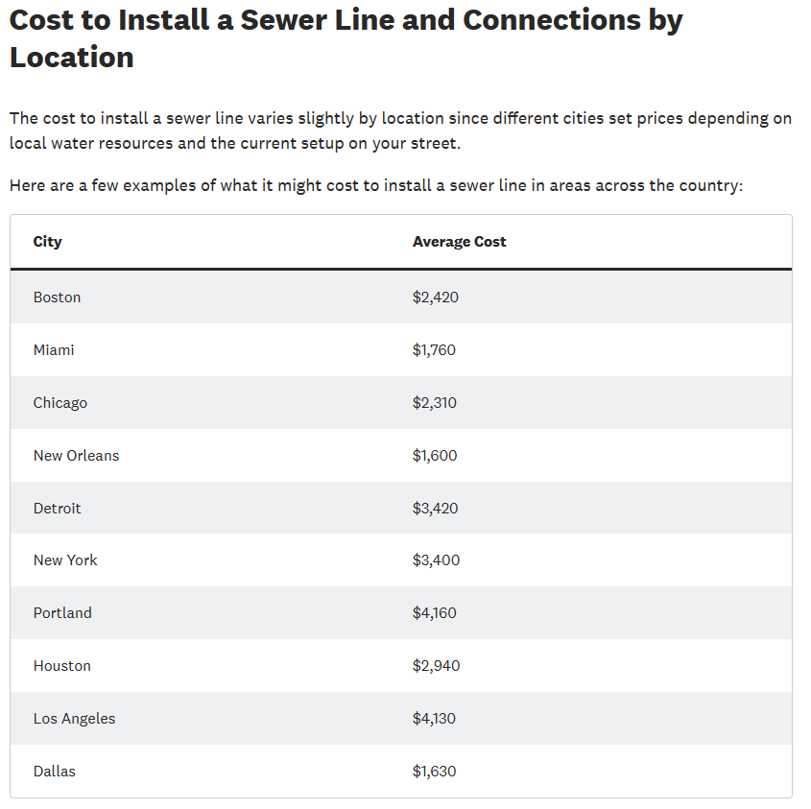
Source: https://www.angi.com/articles/how-much-does-installing-sewer-line-cost.htm

The Question of Where to Put Them
To decide where to put homeless people, you first have to identify where you can’t or shouldn’t put them.
- They should not be in on sidewalks, roadways and easements of private homeowners and businesses. In other words, they should not be blatantly squatting in areas where their presence looks more like a protest against our economic system or government.
- They should not be squatting on privately owned land – depriving legitimate land owners of their private property rights.
But where does that leave them? Well, what about the land owned outright be federal and state governments? Check out this table of how much land the government already owns!
[hide]Federal land ownership by state (as of 2018)
State | Federal land acreage | Total state acreage | Percentage of federal land
Alabama | 880,188 | 32,678,400 | 2.7%
Alaska | 222,666,580 | 365,481,600 | 60.9%
Arizona | 28,077,992 | 72,688,000 | 38.6%
Arkansas | 3,159,486 | 33,599,360 | 9.4%
California | 45,493,133 | 100,206,720 | 45.4%
Colorado | 24,100,247 | 66,485,760 | 36.2%
Connecticut | 9,110 | 3,135,360 | 0.3%
Delaware | 29,918 | 1,265,920 | 2.4%
District of Columbia | 9,649 | 39,040 | 24.7%
Florida | 4,491,200 | 34,721,280 | 12.9%
Georgia | 1,946,492 | 37,295,360 | 12.9%
Hawaii | 829,830 | 4,105,600 | 20.2%
Idaho | 32,789,648 | 52,933,120 | 61.9%
Illinois | 423,782 | 35,795,200 | 1.2%
Indiana | 384,726 | 23,158,400 | 1.7%
Iowa | 97,509 | 35,860,480 | 0.3%
Kansas | 253,919 | 52,510,720 | 0.5%
Kentucky | 1,100,160 | 25,512,320 | 4.3%
Louisiana | 1,353,291 | 28,867,840 | 4.7%
Maine | 301,481 | 19,847,680 | 1.5
Maryland | 205,362 | 6,319,360 | 3.2%
Massachusetts | 62,680 | 5,034,880 | 1.2%
Michigan | 3,637,599 | 36,492,160 | 10.0%
Minnesota | 3,503,977 | 51,205,760 | 6.8%
Mississippi | 1,552,634 | 30,222,720 | 5.1%
Missouri | 1,702,983 | 44,248,320 | 3.8%
Montana | 27,082,401 | 93,271,040 | 29.0%
Nebraska | 546,852 | 49,031,680 | 1.1%
Nevada | 56,262,610 | 70,264,320 | 80.1%
New Hampshire | 805,472 | 5,768,960 | 14.0%
New Jersey | 171,956 | 4,813,440 | 3.6%
New Mexico | 24,665,774 | 77,766,400 | 31.7%
New York | 230,992 | 30,680,960 | 0.8%
North Carolina | 2,434,801 | 31,402,880 | 7.8%
North Dakota | 1,733,641 | 44,452,480 | 3.9%
Ohio | 305,502 | 26,222,080 | 1.2%
Oklahoma | 683,289 | 44,087,680 | 1.5%
Oregon | 32,244,257 | 61,598,720 | 52.3%
Pennsylvania | 622,160 | 28,804,480 | 2.2%
Rhode Island | 4,513 | 677,120 | 0.7%
South Carolina | 875,316 | 19,374,080 | 4.5%
South Dakota | 2,640,005 | 48,881,920 | 5.4%
Tennessee | 1,281,362 | 26,727,680 | 4.8%
Texas | 3,231,198 | 168,217,600 | 1.9%
Utah | 33,267,621 | 52,696,960 | 63.1%
Vermont | 465,888 | 5,936,640 | 7.8%
Virginia | 2,373,616 | 25,496,320 | 9.3%
Washington | 12,192,855 | 42,693,760 | 28.6%
West Virginia | 1,134,138 | 15,410,560 | 7.4%
Wisconsin | 1,854,085 | 35,011,200 | 5.3%
Wyoming | 29,137,722 | 62,343,040 | 46.7%
United States | 615,311,596 | 2,271,343,360 | 27.1%
Source: U.S. Congressional Research Service, "Federal Land Ownership: Overview and Data"

The Definition of a “Home” and How It Has Been Warped Over Time
Aspiration is a wonderful thing. We are better off as a people when we aspire to greatness. People conceive skyscrapers and airports. But we have to acknowledge that the existence of great things does not render small and simple things fully obsolete.
- In a world of Teslas and Ranger Rovers, we do not have contempt for those who restore Ford Model T’s or cherish a classic 67 Chevy Camaro
- In a world of mega yachts and “floating city” cruise ships, at Boy Scout Camp or the local forest preserve, we can still try out a paddle boat or small aluminum fishing boat.
- In a world of $400 YETI Coolers, you can still by a $5 styrofoam cooler at the gas station.
What am I saying here? Just because most of us aspire to live in a large and luxurious house, does not mean it is ok to make small, modest dwellings – even primitive dwellings, ILLEGAL to live in or build!
I would have a very hard time looking a fellow human in the eye and telling them that their only option besides living on the street is to rent an apartment for $1500/mo., especially when they may not have the mental disposition to hold a job, the good health to sustain a job, the residential address to apply for a job. What comes first, the chicken or the egg? How do you pay rent if you can’t come up with a security deposit? How do you interview for a job when you don’t have access to basic hygiene? Should we be admonished by the government that it is not allowable to live in a 500 square foot house with no brick façade – but it is expected that a restaurant owner should overlook that the person he is interviewing to prepare food doesn’t have consistent access to a shower or sink?

The Steppingstones Housing Movement
As an entrepreneur, I have a simple vision. I want to create housing that fills the gap between a cardboard box or tent and the modern building-code-bloated housing.

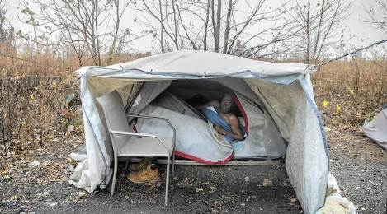 | The Stepping Stones between these two options are woefully lacking in today’s housing market | 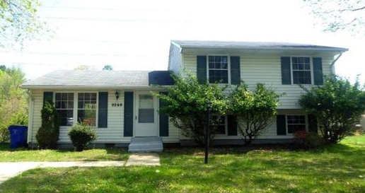

What is wrong with a safe and secure one-room house?
What is wrong with a house with no basement or even no foundation, if that is all someone can afford?
What is wrong with a house that someone obtains without a mortgage?

28% of Americans Make Less Than $35,000 Per Year!
The Median Home Sales Price in 2023 was $430,300
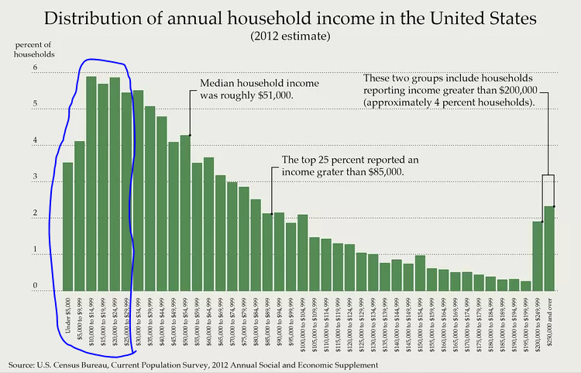

Why are there so few affordable houses being built?
(beyond the building code, which we stated above)
- Land is expensive, so homebuilders are highly motivated to optimize their return on investment by building the most concentrated and expensive homes they can.
- People have very little cash, so mortgages are seen as the primary way to get a home. Once you’re going to borrow the money to buy something, it is easy to just borrow more, and more, and more! Philosophically, it is very impactful to be in a debt with a long term that you cannot clearly envision ever paying off. Having recently paid off my own mortgage, I have been AMAZED at how debt-averse my wife and I have become. We finally own our house, and we find ourselves wanting to stay out of debt. This is a lesson people and governments can learn from…our “debt society” is self-perpetuating!
- Modern utilities and amenities, as a platform, inherently increase the cost to build. Landscaping, sidewalks, parks, schools etc. are a permanent burden on the cost of housing at all levels.

Can’t we just build cute little houses that meet all building codes and municipal expectations?
We can, but let’s look at an example in a central Illinois small city: Champaign, Illinois.
Bristol Place is about the cutest affordable housing development I have ever seen. Looking at it, you can tell that the government agencies that sponsored it really cared about people. And the builder really cared about doing something special. I discovered it one day while on my way to an athletic event at U of I.
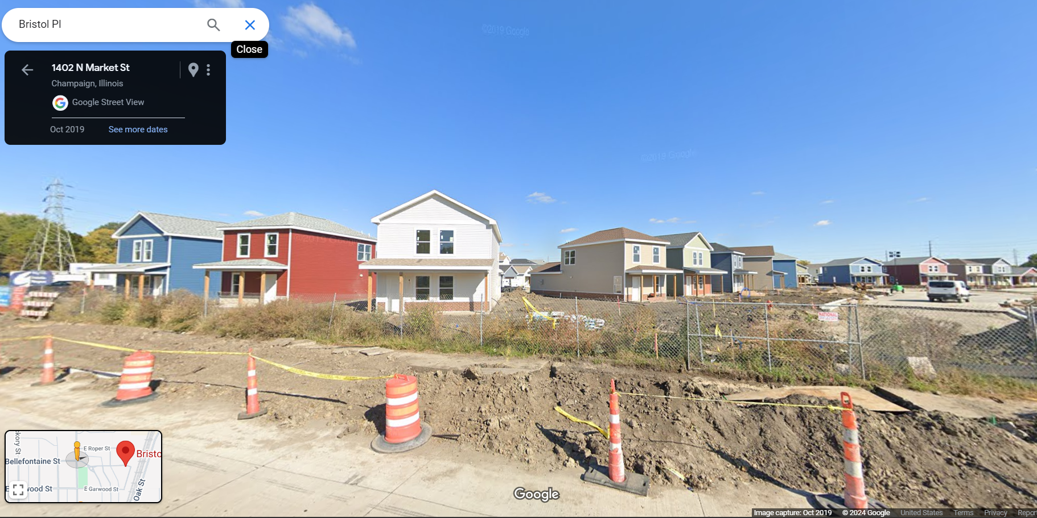
Source: Google Maps
When I saw them (and they look even smaller in person) I thought, “Oh Forget my Cubbie Home, this builder looks like they’ve cracked the code on affordable housing!” Because they built them just like I would if I had the scale of my business to be a traditional homebuilder.
But when I researched it, it cost $23 million to build. There are 90 units and each cost $255,000 to build! Even if that is almost half of the sale price of the average American home in 2024, to a taxpayer, that still looks like an awful lot of money!!! Plainly, you can’t really have a society where those living in $400,000 houses are paying taxes to support homeless and low-income people living in $255,000 houses. You can see how that would just not work, no matter how great your desire to “spread the wealth” 😊
Source:
https://will.illinois.edu/news/story/bristol-place-project-awarded-funding-as-last-family-moves-out
This is why I talk about “building up from $0 dollars and a tent, rather than scaling down from a regular American house.
In Bristol Place, the houses they knocked down to build this neighborhood apparently had an average value of about $30,000. (They were really nasty). But as soon as Bristol Place began occupancy of these beautiful new homes, using housing vouchers and discounted rents, there was immediately hundreds of people on the waiting list. So, what happens, is when you build affordable housing structures that are “too nice” or “too much like a normal house everyone aspires to buy” you have a problem: First, governments don’t have the money to build one for every homeless person or family; Non-homeless people might be tempted to try to lie to get one; people in lower quality public or affordable housing get jealous and want to move into these newer, better units; And I’m sure many people who get those nice Bristol Place homes are probably not motivated to move up anytime soon – so the waitlisted people are going to wait forever.
Maybe being too small and a little inconvenient is a feature and not a flaw!
This leads me to one point that may be really important to solving unsheltered homelessness: We may need a large number of homes that meet basic “shelter from the elements” objectives while not “breaking” the capitalist principles that underly our employment structures and social expectations.
For example, the Cubbie Home we sell is very small – and it does not have its own bathroom (there are common restrooms on-site). If you are living in a Cubbie Home and you are not in a really bad way, the basic comfort it affords may be the foundation on which your desire to better your life begins. If you have your own basic, warm, secure space but you have to wake up in the middle of the night and go out to the restrooms – you might say to yourself, “If I had a full-time job, I could get myself a place with its own bathroom” Whereas if you were truly disaffiliated and unable to work, you might just say “I can live like this indefinitely.” There you go, a separation between those that need the Minimum Viable Housing – and those that will immediately put themselves on a path to the next “stepping stone” up.
When you view this philosophical notion along with the mathematics, it becomes clearer that we’re onto something.
Awesome affordable housing: $255,000 Per Unit (rural Illinois)
Cubbie Home $ 10,000 Per Unit (nationwide)
Savings $245,000 Per Unit
$245,000 per unit saved = affords us money to purchase 24 additional units, or 2 restroom/shower/laundry trailers
Conclusion
I do not have professional credentials in sociology, urban planning or homelessness. I am just a normal person who is very worried about the living conditions of the homeless and the taxpayer money that can be wasted on wrong-headed ideas for solving homelessness. I do not believe the Cubbie Home is a solution for every situation, and I acknowledge that there are many approaches that will need to be tried and learned from. I welcome your feedback, and I promise we will keep developing these white papers to further the discussion of solutions for this issue.

